User story

As a system admin, I would like to be able to view all user accounts, so that I can search for an existing account

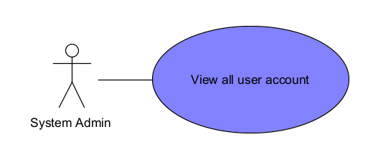

|  |  |
| --- | --- |
| **Name:** System Admin view all user account’s |  |
| **Stakeholders and goals:** System Admin would like to find a user accounts. | |
| **Descriptions:** Enables System admin to search for a user account | |
| **Pre-condition:**   1. System Admin must be logged in. | |
| **Post-conditions:**   1. None | |
| **Trigger:** System Admin click the “All User Account” on the homepage. | |
| **Normal Flow:**   1. System display System Admin homepage. 2. System Admin click “All User Account” button 3. System display “View all User Account” page | |
| **Alternative/Exceptional flows:** | |

BCE Diagram

Sequence Diagram

Wireframe (beta):

